Career Vision

What sparked your interest in tech

My interests in tech started with computer games from a young age but starting a few years ago it started to grow to actually making stuff. It started with tabletop adding text to models to help players remember the stats and abilities of each model, this helps speed up the game by making it faster to look at stats rather than tabbing out and looking for it in the book.

Then I made a game in RPG maker (here a youtube vid of the game (cutscene) https://www.youtube.com/watch?v=-pCd3Lj0lj8) and now I'm taking the course for software development.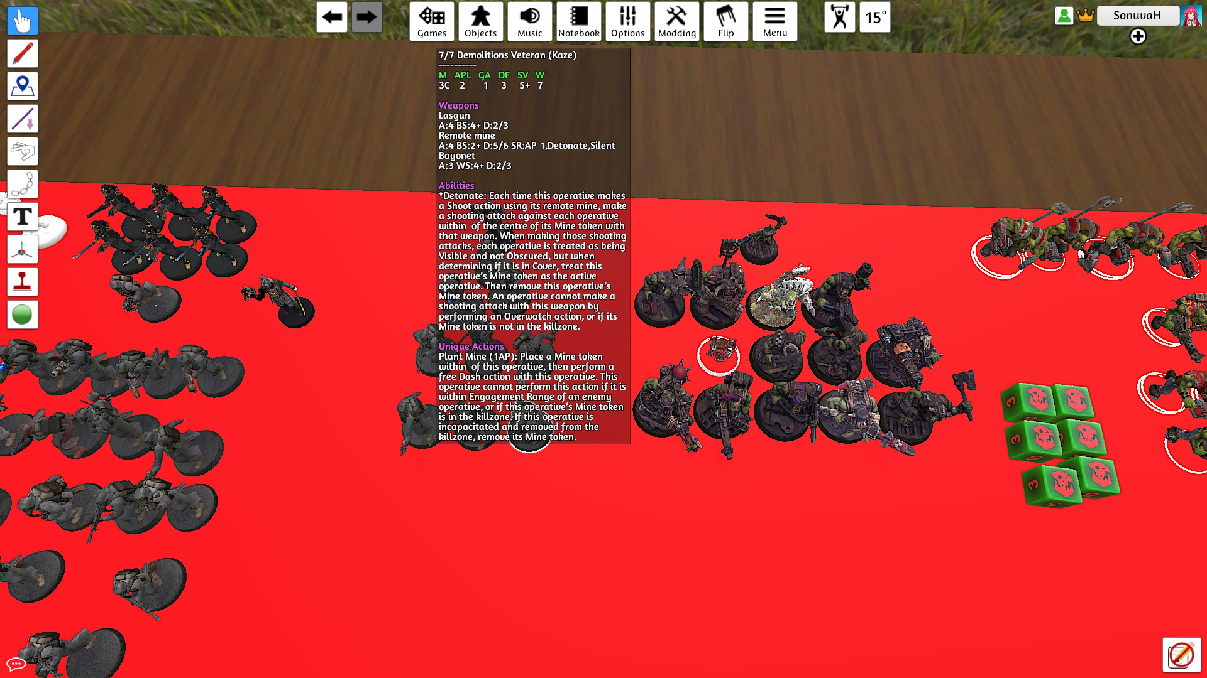

I used to run a guild in World of Warcraft and this has taught me a lot about how to run a function guild this includes:

Communication: Being able to talk to other guild members to explain mechanics in a clear way to make it easier for them to understand and also to hear any problems they have with the game.

Problem solving: Being able to solve problems with the guild or a boss mechanic by talking to the group and planning a strategy to overcome it.

Teamwork: Working together with other people to overcome challenges, I can’t do everything well but by working with other people that can cover my weakness it makes the challenge much easier.

Adaptability: Sometimes I have to fill in roles in the team when people got sick or went on holiday to make sure the guild still defeated bosses.

My idea jobs are:

* Software Developer
* Test Engineer
* User Experience Designer